Benefits
- Minimum capital investment
- No hazardous chemicals stored or handled at your site
- National tank traceability
- Dedicated ion exchange resin capabilities

Benefits
- Completely hands-off - we handle all maintenance and tank exchanges
- Local service branches for resin installation​
- Superior quality - tested to meet stringent performance specifications
- Extensive technical resin application support

Benefits
- Optional conductivity and silica analyzers
- Convenient vessel exchange service
- Proven technology and customer support
- Replaces and regenerates your ion exchange resin tanks off-site whenever they become exhausted
- Our wide range of SDI solutions support flow rates from 0.75 to 250 GPM and resistivity from 50K to 18M Ohm.0
- Simple upgrade for flow and quality
- Flexible configurations
- Easy and convenient cylinder exchange
- Flexible account configurations to respond to your immediate needs
Eclipse Water Technologies
Safe, convenient, and cost-effective supply of high-purity deionized (DI) water for a wide variety of applications, including boiler feedwater, laboratory water, ingredient water for pharmaceuticals, food and beverages, industrial processes, microelectronics manufacturing, and more — even spot-free rinse water for car washes
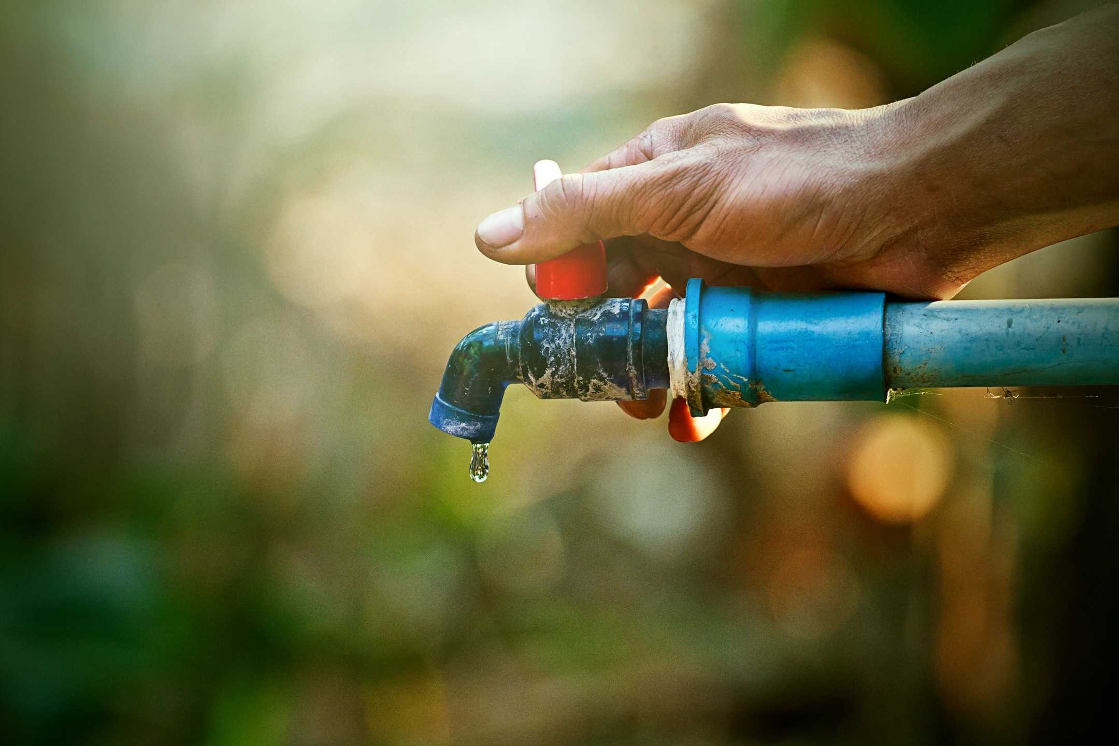
Next Steps...
Friendly and welcoming, please call us and we will do our best to help
Call to Action

